**Worksheet – 2.1**

**Student Name:** Vivek Kumar  **UID:** 21BCS8129

**Branch:** BE-CSE (LEET) **Section/Group:** 809/A

**Semester:** 4th **Date of Performance:** 28/03/2022

**Subject Name:** Computer Network Lab **Subject Code:** 20CSP-257

**1. Aim/Overview of the practical:**

You are a member of a club that has a project to build a MAN, where would this project likely to take place? Elaborate the network with a diagram.

**2. Task to be done/ Which logistics used:**

Create the MAM Diagram and Elaborate it.

**Prerequisites:**

**S/W:**

* Laptop/Desktop
* Online Drowing.io Website

**H/W:**

* Main Memory - 128 MB RAM
* Hard Disk – minimum 20 GB IDE Hard Disk
* 44 MB Floppy Disk Drive
* –52X IDE CD-ROM Drive
* PS/2 HCL

**3. Steps for experiment/Code with Result/Output:**

MAN network likely to take place in the metropolitan area, which could be a single large city, multiple cities, towns and college/university.

Like WANs, a MAN is made up of interconnected LANs. Because MANs are smaller, they are usually more efficient than WANs, since data does not have to travel over large distances. MANs typically combine the networks of multiple organizations, instead of being managed by a single organization.

Most MANs use Fiber optic cables to form connections between LANs. Often a MAN will run on “dark fiber” — formerly unused fiber optic cables that are able to carry traffic. These fiber optic cables may be leased from private-sector Internet service providers (ISP).

**Diagram:**

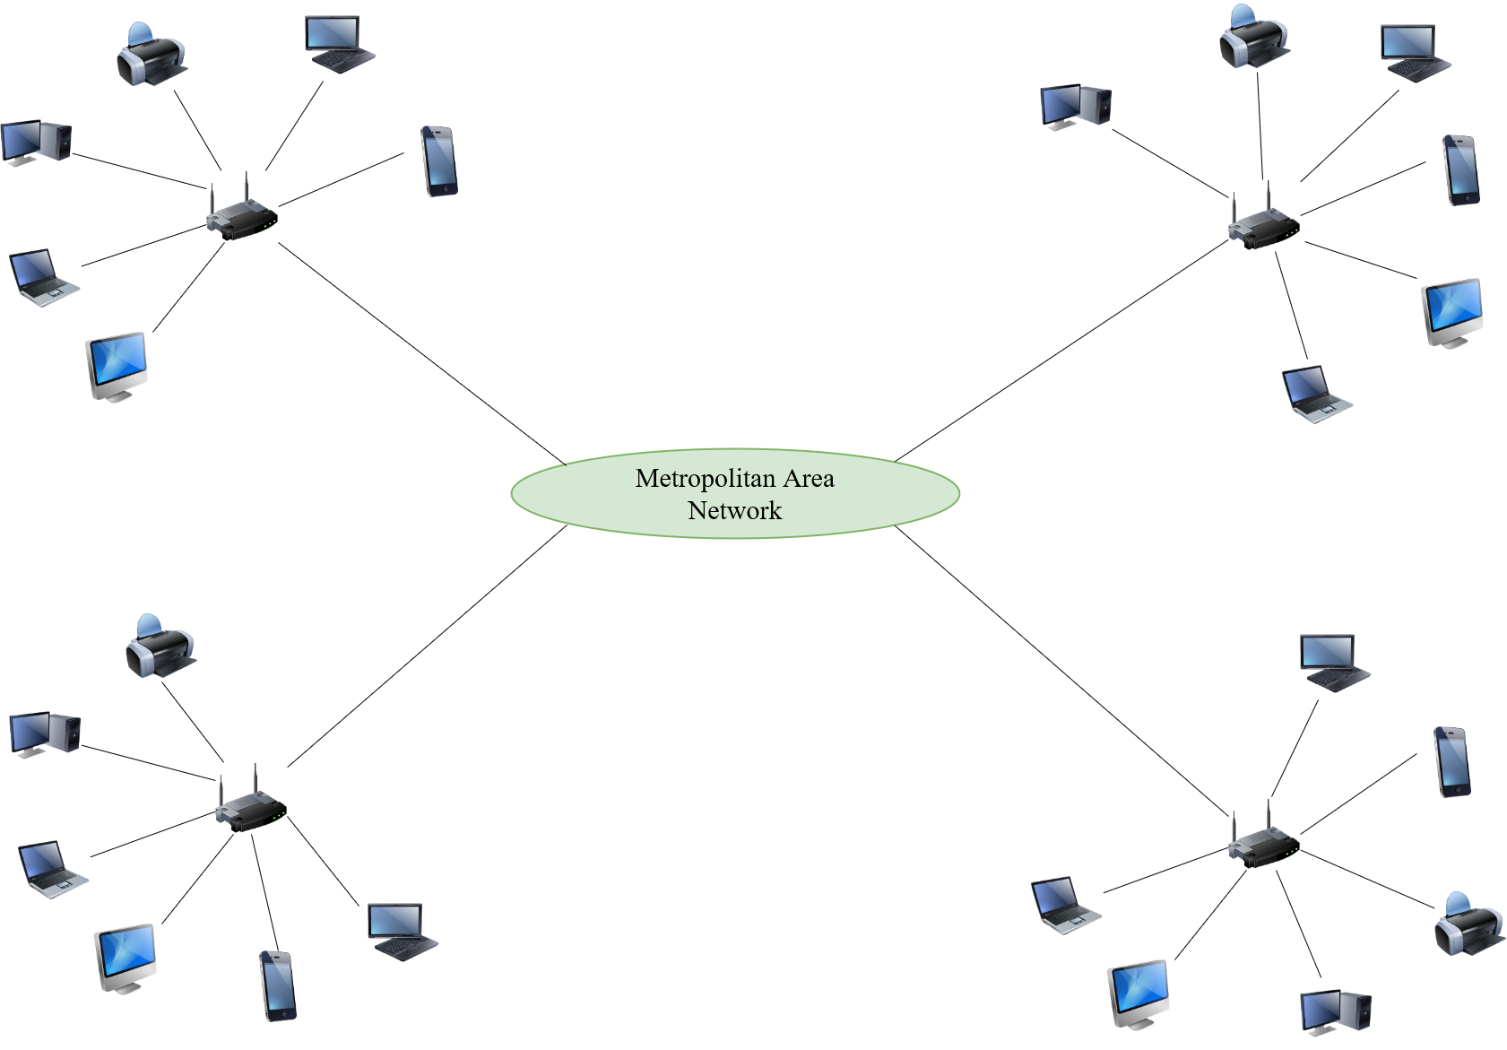

**Learning outcomes (What I have learnt):**

**1.** Understand working of MAN.

**2.** Learnt how to draw a diagram.

**Evaluation Grid (To be created as per the SOP and Assessment guidelines by the faculty):**

|  |  |  |  |
| --- | --- | --- | --- |
| Sr. No. | Parameters | Marks Obtained | Maximum Marks |
| 1. |  |  |  |
| 2. |  |  |  |
| 3. |  |  |  |
|  |  |  |  |